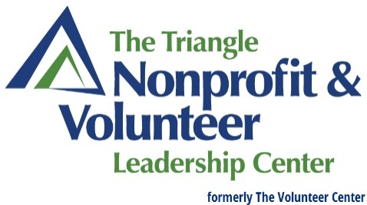

POSITION DESCRIPTION
Position Title: Manager, AmeriCorps Seniors Program
The AmeriCorps Seniors Program Manager is responsible for the daily management of the program, including oversight, administration, planning, development, marketing, and growth. The Manager will also ensure compliance with CNCS guidelines and federal requirements for National Service projects.

Classification: Exempt/Full-time Reports to: Director, Special Programs/Operations
Pay Type: Salary/Monthly Benefits: Competitive Benefits Package

Primary Duties & Responsibilities include:
  - Recruit and work with older adult volunteers
  - Secure community volunteer stations (includes recruitment, presentations, etc.)
  - Maintain and enhance relationships with volunteer stations
  - Identify and help secure additional funding resources for the program
  - Make periodic site visits to the volunteer stations to ensure compliance
  - Conduct new volunteer orientation and volunteer placements at nonprofit volunteer stations
  - Prepare and submit scheduled reports to funding agencies
  - Manage program budget, track spending and order supplies as needed
  - Develop and coordinate Advisory Council
  - Attend/participate in community volunteer events
  - Successfully complete all CNCS AmeriCorps Seniors training (eCourses)
  - Supervise program assistant and volunteers
  - Volunteer administration (background checks, mileage tracking and reimbursements)
  - Organize and provide volunteer recognition
  - Attend community engagement conferences and meetings
  - Oversee program marketing (website, social media, email outreach)
  - Other duties as assigned by Special Program Director & Executive Director

Preferred Knowledge and Skills:
- Strong interpersonal and organizational abilities-attention to detail and multi-tasking
- Marketing/communication (written/oral communication including social media/email/website)
- Problem-solving and critical-thinking skills, as well as being flexible and team oriented
- Strong computer experience using Microsoft Office, email
- Understand organizational mission, goals, and objectives as well as having a commitment to community engagement and social justice issues

Additional Details:
Position includes occasional evening and weekend hours. Applicant must be able to pass a background check and must have a valid North Carolina Driver’s License.

